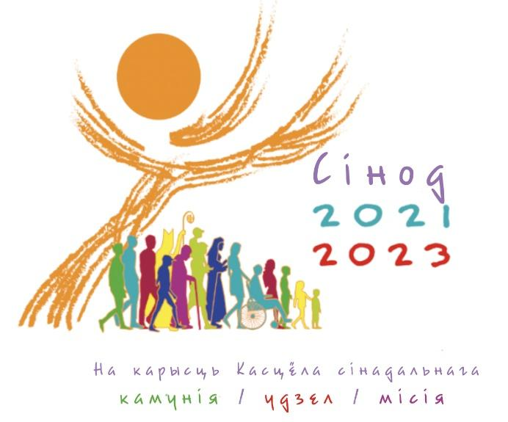

SYNODAL COMMISSION OF THE CATHOLIC CONFERENCE
BISHOPS IN BELARUS

SYNODAL CONSULTATION

Dear friends,

The following questionnaire, offered for discussion, derives from the ten themes proposed by the Synod of the Universal Church. It has been adapted to the reality of the Church in Belarus.
We invite all those who wish to participate in this Synodal Consultation to answer first of all those topics and questions which, more than others, correspond to their own way of life and practice of the faith. Everyone is free to decide which questions to answer and which to omit. There is also an opportunity to address any other topic which may not be explicitly in the Consultation.
Fulfilling the wishes of Pope Francis and our bishops, everyone can take part in the diocesan stage of the Synodal Consultation. You can fill in the questionnaire both independently and jointly (family, monastic community, deanery, religious group or community, etc.).

Please provide the following general information about yourself:

- Male/female (underline the applicable)

- Age ____________________

- A lay person/religious sister/religious brother/seminarian/priest (underline the applicable)

- Place of residence: regional center/district center/countryside (underline the applicable)

- Baptized/unbaptized (underline the applicable)

- Believer/non-believer (underline the applicable)

- Religion __________________________

- Practicing faith regularly/practicing faith from time to time/not practicing faith (underline the applicable)

- Diocese to which I belong (underline the applicable)
- Archdiocese of Minsk-Mohilev
- Diocese of Vitebsk
- Diocese of Grodno
- Diocese of Pinsk
- Apostolic Visitorium for Greek Catholics in Belarus
TEN SYNODAL TOPICS

1 | COMPANIONS ON THE JOURNEY - In the Church and in society we walk side by side on the same road of life and faith.  a) When we say "our Church", who are its parts/members?  b) In our diocese, who are those with whom we “walk together”? Who is near us?  c) Who asks us to accompany them as "companion"?  d) Who are our companions outside the ecclesial reality?  e) As a diocese, what people or what social group(s) could we invite on our journey?  f) As a diocese, what people or social group(s) do we leave “on the sidelines” of our journey, intentionally or accidentally?  g) How well do we know our local reality (work, entertainment, sports, cultural offerings, community experiences, etc.)? What is happening in our vicinity? What activities are people engaged in what are they interested in?  h) Describe your involvement in civic and religious initiatives?
2 | LISTENING - Listening is the first step which requires an open mind and heart, free of prejudice.  a) To what extent do we listen to the lay people of our diocese, especially young people, women, minorities, and persons excluded from public life?  b) In our diocese, how do we relate to the mission of monks? What is our awareness of their contribution to the activities of the Church in our diocese?  c) Describe how we listen to the social and cultural context in which we live?  d) What could be done/changed to improve the faith formation of our communities (those active in the parish as well as those who reside within the parish territory)? How attentively do we listen to the Word of God and the word of man?
3 | SPEAKING OUT - All are invited to speak with courage and parrhesia, that is, in freedom, truth, and charity.  a) How can we promote a more authentic manner of relating within our diocesan ecclesial community and its structures, so that communication takes place without hypocrisy or compromise?  b) How can we promote a more authentic manner of relating with the broader society to which we belong?  c) When and how do we manage to tell the diocesan community what is important to us, what is in our heart?  d) How do we use the gift of speech on social media (not only Catholic): particularly on Facebook, Instagram, Tik Tok, etc.?  e) What is the relationship between the diocese and the media (not only Catholic)? Who represents the Catholic community on social media and how were these people chosen?
4 | CELEBRATING - "Walking together" is only possible if it is guided by communal listening to the God's Word and on communal celebration of the Eucharist.  a) To what extent do we consciously and actively participate in the liturgy?  b) How do prayer and liturgy concretely inspire and guide our “common steps”? How do they influence our most important decisions?  c) How do we contribute to the beauty of liturgical celebrations? How do we promote the active participation of the faithful in the liturgy and in the sanctifying ministry of the Church?  d) How much space is given to the ministry of lay lectors and acolytes?
5 | COMMON RESPONSIBILITY FOR THE MISSION - Synodality is at the service of the mission of the Church, in which all members are called to actively participate.  a) How are all baptized persons invited to be active participants in the mission of our diocesan Church?  b) How does the community of believers support its members who serve in secular roles in society (eg: those who have social and political responsibilities, conduct scientific research and teach, promote social justice, protect human rights, care for the common home, are involved in environmental initiatives, etc.)?
6 | DIALOGUE BETWEEN CHURCH AND SOCIETY - Dialogue is a path of maturity and perseverance, which includes silence and patience, but is able to gather the experience of people and nations.  a) How and where do we dialogue within our diocese?  b) How do we perceive and manage differences of opinion; how do we resolve conflict situations and misunderstandings that arise in our communities?  c) How do we promote cooperation with the representatives of the various religious communities that exist in the territory of our diocese, nurture cooperation between them, and encourage their cooperation with lay movements and associations?  d) Do we have experiences of dialogue and shared charitable (or other) ministry with believers of other religions and/or with those who have no religious affiliation?  e) How does our diocese dialogue with various public institutions? What can we learn from them in the field of politics, economics, culture, the development of civil society, and outreach to people who live in poverty?
7 | RELATIONSHIPS WITH OTHER CHRISTIAN CONFESSIONS - The dialogue between Christians of different confessions, united by one baptism, has a special place in the synodal journey.  a) What relationships do we have with the brothers and sisters of other Christian denominations?  b) What are the areas of concern?  c) What fruits has this “walking together” brought?  d) What are the difficulties?
8 | AUTHORITY AND PARTICIPATION - A synodal church is a Church in which everyone has the right to be a full member and to assume responsibility appropriate to their state.  a) How is authority exercised within our diocesan Church?  b) How well do we recognize common goals, establish the means to pursue them, and determine the steps to be taken towards their fulfilment?  c) How do the Presbyteral Council and Diocesan Pastoral Council participate in the ministry of our diocese?  d) How are teamwork and co-responsibility put into practice in our diocese?  e) How does the participation of lay people in Pastoral Councils improve the life of the diocese?
9 | DISCERNING AND DECIDING - Synodality presupposes that decisions are made through discernment, which results from the common obedience to the Holy Spirit.  a) What processes and methods do we use for shared discernment and decision-making?  b) How do we promote participation in decision-making within hierarchically structured communities?  c) How can we improve the discernment and decision-making processes in the diocese?
10 | BUILDING OF SYNODALITY - The spirituality of the "common journey" is intended to become an educational principle for the formation of the individual Christian as well as Christian families and communities.  a) How can we encourage people, especially those who have leadership roles in the Christian community, to be more capable of “walking together”, listening to one another, and engaging in dialogue?  b) What processes of education and formation do we offer to foster discernment and the exercise of authority in our communities?  c) What tools help us to recognize the dynamics of the culture in which we live and their influence on our style of being Church?
OTHER - In the common journey, everyone, through the inspiration of the Holy Spirit, has the opportunity to express their comments, opinions, and wishes.

Add your suggestions, areas of concern here, and proposals here.

